Darkness Detecting Circuit:

# Objective:

To detect the absence of light and illuminate the LED.

# Circuit:

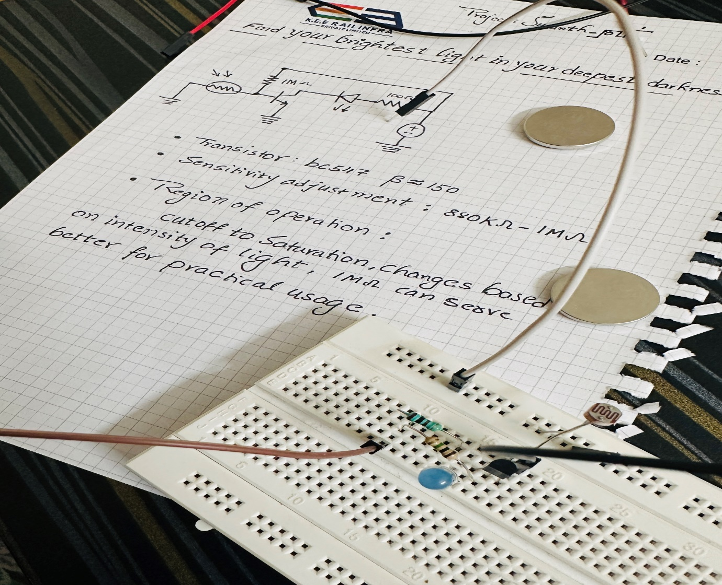

# Hardware Connections:

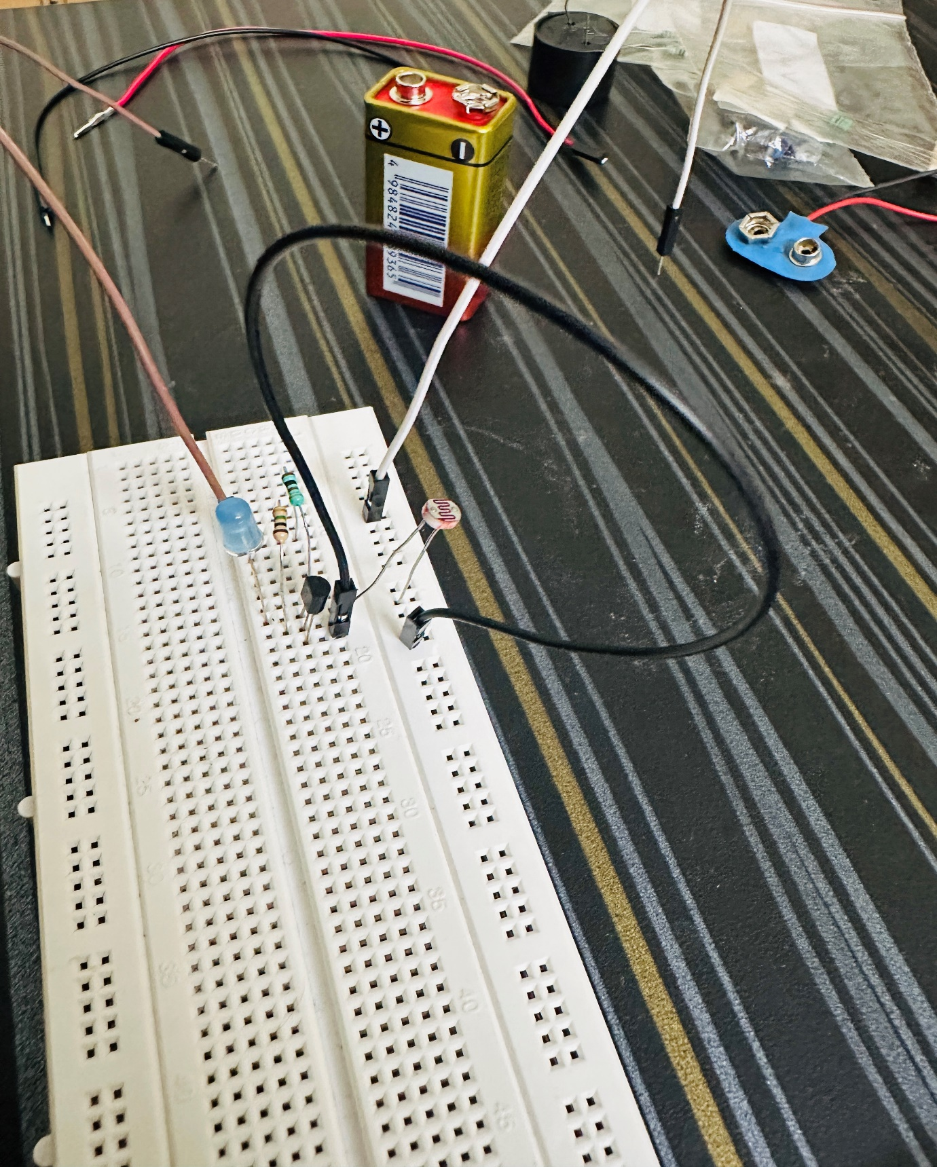

# Modified to Compact device and Device is in action:

